Analisa rangkaian

1. DC IN (pin Header)

1. Resistor

1. DC-DC (Regulator 12v ke 5v)

1. A screenshot of a computer

   Description automatically generatedDiode

1. Kapasitor Elco

1. A screenshot of a computer

   Description automatically generatedATmega 328

1. A screenshot of a computer

   Description automatically generatedA diagram of a circuit

   Description automatically generatedRegulator

1. A screen shot of a computer

   Description automatically generatedMicro SD card
2. TCA95

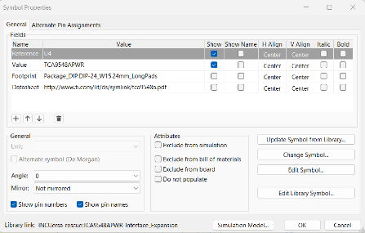

1. A screenshot of a computer

   Description automatically generatedHeader 4 pin

